# Capstone Requirements

Research Question: “How might Seattle-area students in age 8-12 achieve learning about debris' impacts on marine wildlife while contributing to citizen science projects so that they can develop a sense of connection to the natural world through active learning while meaningfully contributing to science research?”

[You can see notes from our literature review, market research, and initial user research here.](https://github.com/UW-AppleJACK/public-archive/blob/main/Marine%20Rescue%20-%20research%20board.pdf) The literature review included learning about gamification, children in citizen science, and teaching kids STEM subjects.

Our deliverables include a video, a poster, and our deployed project:

* [Project Video](https://www.youtube.com/watch?v=kL82SNkr5wo)
* [Project Poster](http://to.marinerescue.app/poster)
* Thumbnail Logo
  + 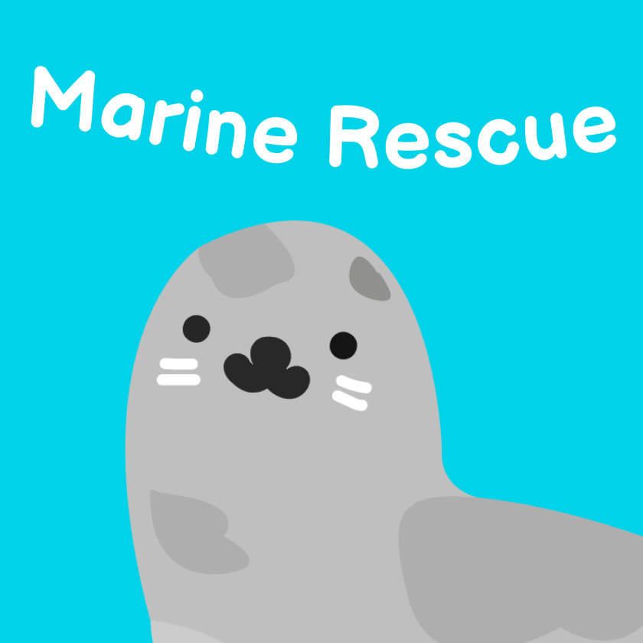
  + 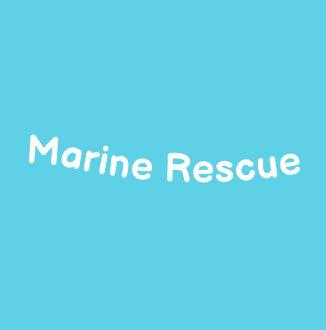
  + 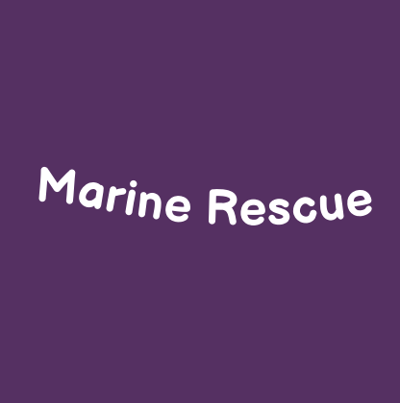
  + 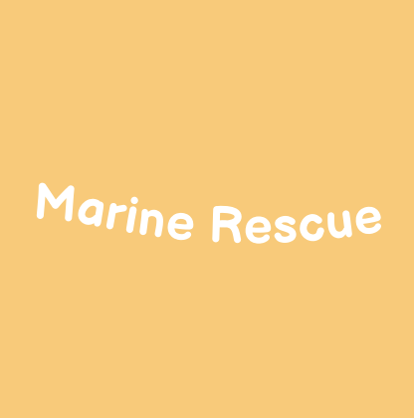
* [Live Project: marinerescue.app](https://marinerescue.app/)
  + [Level Editor](https://marinerescue.app/storyteller/editor)
* [Project Code on GitHub](https://github.com/UW-AppleJACK/applejack)

You can view all of these along with a description on [the iSchool Capstone submission](https://ischool.uw.edu/capstone/projects/2021/loopy-or-floppy-join-strawberry-harbor-seal-learn-about-impacts-marine), as well.

# Future Work

* We intentionally chose to work on a digital, at-home learning platform. We also considered ways the project could be integrated into school curriculums (i.e. by developing lesson plans aligned with educational standards) or physical kits and activities for kids to try.
* Although we did implement a kid-oriented marine debris classification game, we were not able to get to integrating the activity into Zooniverse. We have some generic JSON data files that might be a helpful basis implementing classification in any other framework, including Zooniverse: [DebrisClassificationImagesData](https://github.com/UW-AppleJACK/applejack/blob/main/marinerescue-frontend/src/data/DebrisClassificationImagesData.js), [DebrisClassificationOptionsData](https://github.com/UW-AppleJACK/applejack/blob/main/marinerescue-frontend/src/data/DebrisClassificationOptionsData.js)
* We had concepts for additional stories that we did not design or implement:
  + Value of engagement with citizen science: story of individual or organizational impact
  + Impact of beach activities: What does a firepit leave? What do other activities leave? Leave No Trace principles
  + Beach Ecology: What is the food web? How do species interact with each other? How do human activities influence the ecosystem? Highlight cute endangered animals.

**Contact Info**

* Cheryl Wu ([cheritwithwu@gmail.com](mailto:cheritwithwu@gmail.com))
* Jacinda Eng ([jacindaeng@gmail.com](mailto:jacindaeng@gmail.com))
* Kiran Pradhan ([pradhan.kiran786@gmail.com](mailto:pradhan.kiran786@gmail.com))
* Andrey Butenko ([andreyxbutenko@gmail.com](mailto:andreyxbutenko@gmail.com))